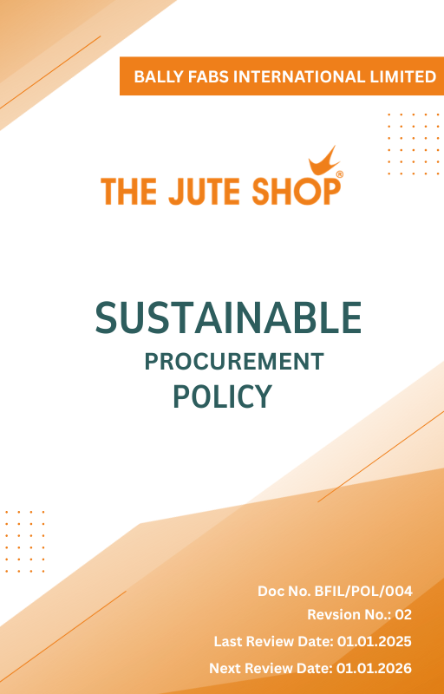
Contents

Introduction 3
Scope 3
Policy Statement 3
Key Focus Areas 4
Qualitative Objectives 4
Quantitative Targets 5
Alignment with the United Nations Sustainable Development Goals (SDGs) 6
Responsibilities 6
Review Mechanism 6
Revision History 7
Employee Acknowledgment Form 8

Introduction
Ballyfabs International Limited is the leading manufacturer and wholesaler of Canvas Cotton Bags, Jute Bags, and more. We are committed to ensuring that our procurement practices contribute to sustainable development. This policy outlines our commitment to integrating environmental and social considerations into our procurement decisions.

Scope
This policy applies to all workers, employees, directors, officers, agents, contractors, and any third parties acting on behalf of Ballyfabs Int. Ltd. (BFIL). It covers all business activities, including procurement, sales, marketing, and any interactions with government officials, customers, suppliers, and other stakeholders. The policy is applicable globally, regardless of local business practices or cultural norms. This policy applies to the below-mentioned locations :

Site | Address
Bally Fabs International Limited | - 3, Haren Mukherjee Road, Belur, Howrah-711202, West Bengal, India.
Bally Fabs International Limited | - Vill-gangarampur, PO-Dakshin Alipore, ps-Bishnupur, Dist-South 24 Parganas, Pin-743503, West Bengal, India

Policy Statement
Ballyfabs International Limited is dedicated to sustainable procurement practices that support our environmental and social responsibility goals. We aim to work with suppliers who share our commitment to sustainability and ethical practices.

Key Focus Areas
- Supplier Environmental Practices: Integrate environmental considerations into procurement processes (e.g., price, quality, reliability). Assess and improve supplier environmental performance.
- Supplier Social Practices: Uphold labor and human rights standards within the supply chain. Ensure fair working conditions and respect for human rights among suppliers.
- Supply Chain Transparency: Enhance transparency within the supply chain and conduct audits to verify supplier compliance.
- Community Engagement: Support for community-based suppliers and inclusion of diverse, small, and responsible enterprises in the supply base.

Qualitative Objectives
- Supplier Environmental Practices
- Promote environmentally sustainable procurement by partnering with suppliers who demonstrate measurable environmental responsibility.
- Encourage continuous improvement in supplier environmental performance through training and collaboration.
- Emphasize sourcing from suppliers with recognized environmental compliance certifications.

- Supplier Social Practices
- Ensure that all suppliers adhere to fair labor practices, including the prohibition of child and forced labor, provision of fair wages, and assurance of safe working environments.
- Support supplier initiatives that improve workforce welfare and social accountability.

- Supply Chain Transparency
- To build a transparent, ethical, and accountable supply chain by ensuring suppliers comply with environmental, labor, and human rights standards, while fostering trust with stakeholders through open reporting.

- Community Engagement
- Increase engagement with community-based and small-scale suppliers.
- Support diversity and inclusion by integrating underrepresented suppliers into the supply base.
- Foster long-term partnerships with suppliers who demonstrate social and environmental responsibility.

Quantitative Targets
To translate our commitment into measurable progress, Bally fabs International Ltd has defined specific objectives and targets aligned with our key focus areas. These goals are designed to promote ethical sourcing, strengthen supplier accountability, and support environmental and social sustainability across our supply chain by year 2030, using year 2023 as the baseline year.

- Supplier Environmental Practices
- By 2030, reduce the environmental impact of procured materials by 30% compared to 2023 levels and ensure 50% of suppliers meet environmental standards.
- Increase procurement from ISO 14001 certified suppliers by 50% by year 2030.

- Supplier Social Practices
- By 2030, achieve 100% supplier compliance with labor and human rights standards and maintain zero violations related to working hours and wages.
- Reach 50% verified compliance with labor and human rights benchmarks among suppliers by year 2030, with ongoing monitoring and engagement.

- Supply Chain Transparency
- By 2030, extend sustainability compliance audits to 80% of critical suppliers.

- Community Engagement
- Maintain implementation of community engagement programs in 100% of production sites by 2030.
- Increase national sourcing by 50% by year 2030
- Ensure 15% of supplier base includes small or diverse businesses by year 2030.

Alignment with the United Nations Sustainable Development Goals (SDGs)
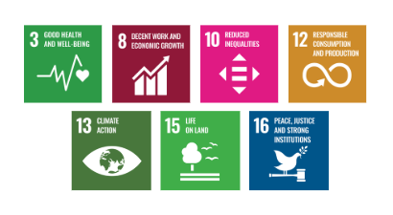
The sustainability objectives and performance targets align with the following Sustainable Development Goals (SDGs):

Responsibilities
- Procurement Team is responsible for integrating responsible sourcing principles into supplier selection, contract terms, and ongoing evaluations.
- Sustainability Team monitors supplier performance on environmental, social, and ethical parameters and supports improvement initiatives.
- Suppliers are expected to comply with Bally Fabs International Ltd sourcing standards, provide required disclosures, and cooperate during audits and assessments.
- Senior Management ensures oversight, resource allocation, and enforcement of the policy through regular reviews and strategic direction.
- All Employees involved in sourcing or supplier engagement are expected to uphold this policy and report any violations or concerns through established channels.

Review Mechanism
The EHS Officer reviews this policy annually to assess its effectiveness. This includes evaluating procurement practices, adapting to changing market demands, and ensuring compliance with evolving environmental and social regulations. These reviews guide continuous improvements, track progress towards sustainability goals, and uphold BFIL’s commitment to sustainable stewardship in procurement.

Revision History

Amendment of Revision No. | Effective Date | Details of Amendment of Revision
01 | 01.01.2024 | Scope
01 | 01.01.2024 | Key Focus Areas
01 | 01.01.2024 | Review Mechanism
02 | 01.01.2025 | Key Focus Areas
02 | 01.01.2025 | Qualitative Objectives
02 | 01.01.2025 | Quantitative Targets & Target Year
02 | 01.01.2025 | Responsibilities
02 | 01.01.2025 | Alignment with the United Nations SDGs
02 | 01.01.2025 | Monitoring, Reporting, and Transparency

Effective Date | : 01.01.2025
Next Review Date | : 01.01.2026
Revision No. | : 02

Approved By :

Employee Acknowledgment Form
I, acknowledge that I have read, understood, and agree to adhere to the company’s Sustainable Procurement Policy. I recognize the importance of my role in supporting the company’s commitment and am committed to actively participating in its implementation. I will strive to incorporate sustainable procurement practices into my daily work, comply with relevant regulations and company policies, and support continuous improvement of environmental performance.
I understand that my commitment is essential to achieving the company’s sustainability objectives and fostering a culture of responsibility. I am dedicated to contributing to our shared vision of a sustainable future and demonstrating our dedication to sustainable stewardship.

Employee Name | : _________________________
Employee ID | : _________________________
Department | : _________________________
Signature | : _________________________

